PipeLine Reports 7-3
Introduction 7-3
Stock Status Report 7-4
Creating the Stock Status Report 7-4
Products and Types 7-6
Excluding Planned Shipments 7-8
Shipment Summary Report 7-8
Creating a Shipment Summary Report 7-9
Limiting the Report‘s Scope 7-10
Shipment Orders Report 7-11
Creating a Shipment Orders Report 7-11
Annual Shipment Costs Report 7-12
Creating an Annual Shipment Costs Report 7-12
Limiting the Report‘s Scope 7-13
Pipeline Action Report 7-14
Creating a Pipeline Action Report 7-15
Limiting the Report‘s Scope 7-15
Pipeline Problem Report 7-16
Creating the Pipeline Problem Report 7-16
Limiting the Report‘s Scope 7-17
Procurement Table Report 7-17
Creating a Procurement Table Report 7-18
Limiting the Report‘s Scope 7-18
Showing and Hiding Report Data 7-19
Showing Report Data 7-19
Hiding Report Data 7-20
Previewing and Printing PipeLine Reports 7-20
Previewing a Report 7-20
Office Links 7-22
Printing a Report 7-22
Creating PDF of a Report 7-22

Pipeline reports
Figure 7-1—Stock Status screen 7-6
Figure 7-2—Display options 7-6
Figure 7-3—Display options 7-7
Figure 7-4—Select Suppliers to Exclude box 7-8
Figure 7-5—Shipment Summary screen 7-9
Figure 7-6—Display options 7-9
Figure 7-7—Shipment Orders screen 7-11
Figure 7-8—Annual Shipment Costs screen 7-13
Figure 7-9—Pipeline Action screen 7-15
Figure 7-10—Pipeline Problem screen 7-17
Figure 7-11—Procurement Table screen 7-18
Figure 7-12—End of Year field 7-19
Figure 7-13—Example of Show Data display 7-20

PipeLine Reports

Introduction
This section describes the PipeLine reports and provides guidance on how to interpret and use these reports for pipeline monitoring and procurement planning.

The following PipeLine reports are available:

Stock Status
Spreadsheet by month or quarter showing detailed figures on which the Stock Status graph is based.

Shipment Summary
Report showing shipment costs, including product and freight costs, for selected supplier/status or product/status.

Shipment Orders
Report showing quantities and cost of orders for a selected supplier/status.

Annual Shipment Costs
Report showing the actual or estimated cost of shipments received or expected during a calendar year.

Pipeline Action
Report showing the next procurement action needed for products in your system.

Pipeline Problem
Report highlighting actual, or expected serious pipeline problems (e.g., stockouts, shortfalls, or surpluses), for products in your program.

Procurement Table
Report that generates data in the format used in USAID‘s contraceptive procurement tables (CPT).

Stock Status Report
This report is PipeLine’s primary output. It includes the data maintained by PipeLine for a single product or type and for a selected period of calendar years. This report (on which a Stock Status graph is based) displays detailed figures for a selected product or type. Based on the product’s commodities records, the report calculates the months of stock represented by the ending balance for each period, with shortfalls or surpluses, based on the product minimum and maximum levels.

Each row represents one period and displays the beginning balance, details (quantity, status and supplier) regarding shipments received or due, actual or forecast consumption, stock adjustments, stock in months, desired stock, shortfall/surplus, and ending balance. The desired stock shows the quantity needed in the period for the ending balance to meet the product’s maximum desired quantity, and the Shortfall/Surplus is equal to the difference between the ending balance and minimum desired quantity, or the maximum desired quantity. Shortfalls are expressed in negative numbers. Surpluses are expressed in positive numbers. Shipments are displayed on the row of the period they have been (or are expected to be) received, regardless of the shipment’s status or lead time.

Use this report for detailed procurement planning for each product. The Stock Status report displays the supplier and shipment status for each shipment. If shortfalls are projected, plan additional shipments, or advance the receipt date of expected shipments. If a surplus is projected, postpone a shipment, or reduce the quantity you expect to receive. If there are excessive unexplained adjustments, investigate the quality of your data.

Creating the Stock Status Report
The Stock Status report is based on the last product or method updated or displayed. The default time period is five years, which includes the current year, previous two years, and following two years. Using stock data, you can create a stock status report for any product in your program.

The following explains how to create a Stock Status report.
 | The procedure for creating a Stock Status report is the same for every product you choose.

From the Tree View—

- Click on the Stock Status Tree View option (under Reports) to display the Stock Status screen (see Figure 7-1).

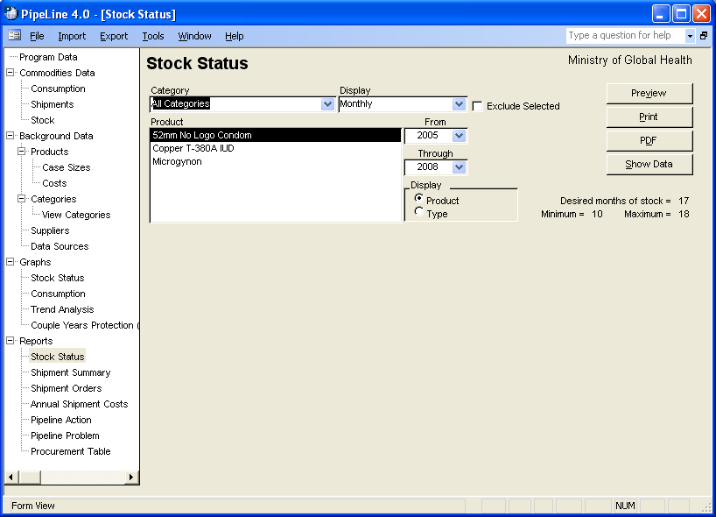
Figure 7-1—Stock Status screen
- Click on the arrow next to the Category field, and select a category from the pull-down menu.
Or, select All Categories from the Category pull-down menu to access all products in your program.

The Display field enables you to create a report displaying stock data on a monthly or quarterly basis.

- Click on the arrow next to the Display field, and select Monthly to display the data by month or Quarterly to display the data by quarter.

Products and Types
PipeLine gives you the option of selecting items by Product or Type (see Figure 7-2).
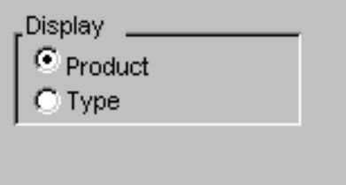
Figure 7-2—Display options

The Product option is selected by default. To display data by Type, which is a list of Types filtered by Category,—

- Click on the Type option.
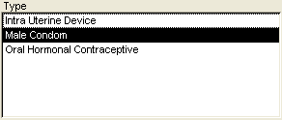
Figure 7-3—Display options
PipeLine changes the label of the Product box to Type and displays all Types associated with the selected category (see Figure 7-3).

The Product/Type box shows which product(s) you can select to create a stock status report.

- Click on the Product or Type you need to create the report.

The From and Through fields let you determine the span of time the report will cover.

- Click on the arrow next to the From field, and select the starting year of the report period.

- Click on the arrow next to the Through field, and select the last year of the report period.

Excluding Planned Shipments
The Exclude Selected field enables you to exclude planned shipments from the Stock Status report by excluding the suppliers of these shipments from the output.

- Click on the Exclude Selected field.
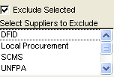
Figure 7-4—Select Suppliers to Exclude box
The Select Suppliers To Exclude box opens, showing the suppliers of your products (see Figure 7-4).

- Click on the suppliers whose planned shipments you want excluded from the report.

To select more than one supplier—

- Hold down the Control key (<Ctrl>), and click on each supplier you want excluded from the report.

See page 25 for information on using the Show Data and Hide Data buttons.

See page 27 for information on previewing, printing, or creating a PDF of the Stock Status report.

Shipment Summary Report
The Shipment Summary report calculates the cost of products and freight for selected shipments. Data in this report can be displayed by supplier or product.

Shipment Summary by Supplier
This report groups shipments and subtotals costs by supplier. This is useful if you have products with multiple suppliers but you need to look at costs associated with individual suppliers. Use this report when you review shipment information with suppliers and estimating costs and budgeting.

Shipment Summary by Product
This report groups shipments by product, regardless of supplier. This is useful if you have products with multiple suppliers but you need to see costs associated with individual products. Use this report to review shipments input to PipeLine and to check their expected receipt dates, quantities, status, etc.

Creating a Shipment Summary Report
You can use PipeLine to create a Shipment Summary report (grouped by supplier or product).

From the Tree View—

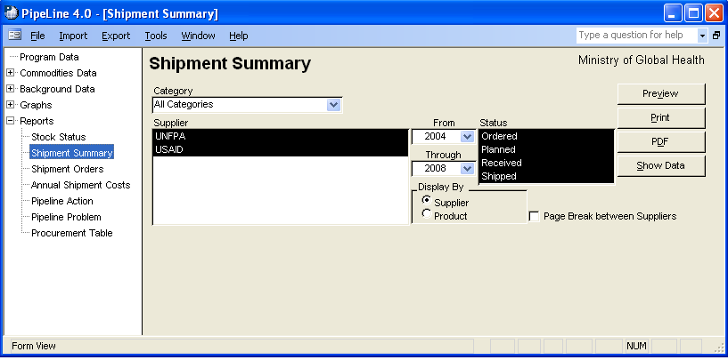
- Figure 7-5—Shipment Summary screen Click on the Shipment Summary Tree View option to display the Shipment Summary report screen (see Figure 7-5).

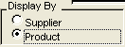
- Figure 7-6—Display options Click on the arrow next to the Category field, and select a category from the pull-down menu.
Or, select All Categories from the Category pull-down menu to access all the products in your program.

By default, the Shipment Summary report is set for all suppliers, with all shipment status types pre-selected.

To create a report grouped by products—

- Click on the Product field in the Display By area of the Shipment Summary report screen (see Figure 7-6) to create a report grouped by products.

Regardless of the type of report you choose to create, you can fine-tune the report.

- For reports by supplier, click on the Page Break Between Suppliers field to include a page break after each supplier included in the report.
Or, for reports by products, click on the Page Break Between Types field to include a page break after each Type included in the report.

Limiting the Report‘s Scope
You can limit the scope of the report.

To limit the number of suppliers or products included in the report—

- For Suppliers, click on the supplier you want included in the report.
Or, for Products, click on the product you want included in the report.

To select multiple suppliers or products—

- Hold down the <Ctrl> key, and click on each supplier you want included in the report.
Or, hold down the <Ctrl> key, and click on each product you want included in the report.

To limit the shipment statuses included in the report—

- In the Status field, click on the status you want included in the report.

To select multiple statuses—

- Hold down the <Ctrl> key, and click on each status you want included in the report.

The From and Through fields define the reporting period. By default, the reporting period begins on the year of your first shipment and ends on the year your last shipment was received, or is expected to be received.

To change the reporting period—

- Click on the From field, and select the start year from the pull-down menu.

- Click on the Through field, and select the end year from the pull-down menu.

See page 25 for information on using the Show Data and Hide Data buttons.

See page 27 for information on previewing, printing, or creating a PDF of the Shipment Summary report.

Shipment Orders Report
This report can be used as a draft order for new shipments, and it can be used to confirm information on previous shipments.

Creating a Shipment Orders Report
You can use PipeLine to create the Shipment Orders report.

From the Tree View—

- Click on the Shipment Orders Tree View option.

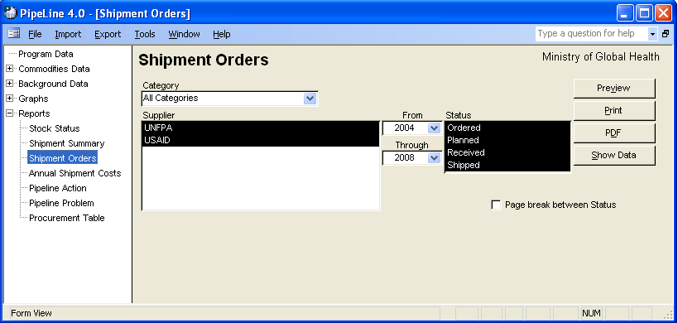
Figure 7-7—Shipment Orders screen The Shipment Orders report screen is displayed (see Figure 7-7).

By default, the Shipment Orders report is set for all suppliers, with all shipment statuses selected.

To create a report for a specific supplier—

- Click on the arrow next to the Category field, and select a category from the pull-down menu.
Or, select All Categories from the Category pull-down menu to access all the products in your program.

- In the Supplier field, click on the supplier you want included in the report.

To select multiple suppliers—

- Hold down the <Ctrl> key, and click on each supplier you want included in the report.

To limit which shipment statuses are included in the report—

- In the Status, click on the status you want included in the report.

To select multiple statues—

- Hold down the <Ctrl> key, and click on each status you need included in the report.

The From and Through fields define the reporting period. By default, the reporting period begins on the year of your first shipment and ends on the year your last shipment was received, or is expected to be received.

To change the reporting period—

- Click on the From field, and select the start year from the pull-down menu.

- Click on the Through field, and select the end year from the pull-down menu.

The Page Break between Status field enables you to include page breaks in the report.

- Click on the Page Break Between Status field to include a page break after each shipment status included in the report.

See page 25 for information on using the Show Data and Hide Data buttons.

See page 27 for information on previewing, printing, or creating a PDF of the Shipment Order report.

Annual Shipment Costs Report
The Annual Shipment Cost report calculates annual shipment costs, by supplier. It calculates the total cost (product value and freight) of shipments received, or expected to be received, in a calendar year. It shows yearly totals, not the cost of individual shipments. Costs associated with the procurement and delivery of a shipment (e.g., taxes, customs clearance fees) should be included in the freight cost. Use this report when you talk to suppliers to help assess the annual costs of supplying your program. If you procure your own commodities, this report may be helpful for budgeting.

Creating an Annual Shipment Costs Report
By default, the Annual Shipment Costs report is set for all suppliers, products, and shipment statuses.

From the Tree View—

- Click on the Annual Shipment Tree View option.

The Annual Shipment Costs screen is displayed (see Figure 7-8).

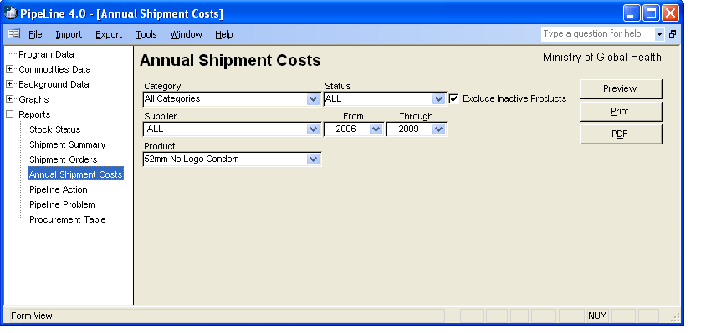

Figure 7-8—Annual Shipment Costs screen Limiting the Report’s Scope
You can limit the scope of the report.

- Click on the arrow next to the Category field, and select a category from the pull-down menu.
Or, select All Categories from the Category pull-down menu to access all the products in your program.

- Click on the arrow next to the Supplier field, and select a supplier from the pull-down menu.

- Click on the arrow next to the Product field, and select a product from the pull-down menu.

- Click on the Exclude Inactive Products field to have the report list only those products that are currently active.

- Click on the Status field, and select the shipment status you need.
 | You may choose one or all items from the category, supplier, product, and status menus.

The From and Through fields show the reporting period. The default reporting period for an Annual Shipment Cost report is five years.

To change the reporting period—

- Click on the arrow next to the From field, and from the pull-down menu, select the starting year of the report period.

- Click on the arrow next to the Through field, and from the pull-down menu, select the last year of the report period.

See page 27 for information on previewing, printing, or creating a PDF of the Annual Shipment Costs report.

Pipeline Action Report
The Pipeline Action report creates a comprehensive analysis of product pipelines and information on needed actions. It shows the procurement actions needed next for the products you monitor, organized by the date of the action needed next. Possible actions include—

Plan Shipment
A shipment needs to arrive in the month specified to prevent stock levels from dropping below minimum and to bring them back to the maximum level. Based on lead times, this planning should be done no later than the action date. Before taking action, review the Stock Status report to determine the impact this will have on future stock status.

Confirm Shipment Ordered
A shipment planned to arrive on the receive date should be ordered no later than the action date. Ensure that the shipment was ordered. Update the status and date ordered on the Shipments form.

Confirm Shipment Dispatched
A shipment ordered to arrive on the receive date should be shipped no later than the action date. Ensure that the shipment was dispatched. Update the status and date shipped on the Shipments form.

Confirm Shipment Received
A shipment shipped to arrive on the receive date should be confirmed upon arrival. Ensure that the shipment was received. Update the status and date received on the Shipments form.

Surplus, Change
An arriving shipment will push stock levels above the maximum desired level. Determine if you should cancel or postpone the shipment, or transfer stock to another program. Update the PipeLine data accordingly.

Use this report to guide your pipeline monitoring activities. With good data, you can take each required action on or before the date the action is required to prevent stock imbalances before they occur. You should, however, review the Stock Status report and graph before taking procurement actions.

Creating a Pipeline Action Report
This report is generated based on all shipments and needed quantities for active products, and it is displayed on the screen. Received shipments are not included.

From the Tree View—

- Click on the Pipeline Action Tree View option.

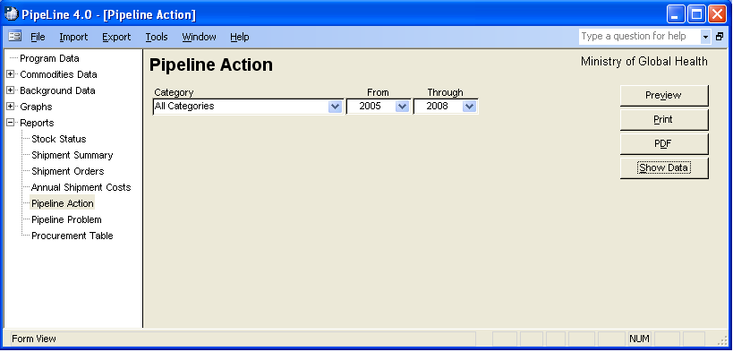
Figure 7-9—Pipeline Action screen The Pipeline Action screen is displayed (see Figure 7-9).

Limiting the Report’s Scope
You can limit the scope of the report.

- Click on the arrow next to the Category field, and select a category from the pull-down menu.
Or, select All Categories from the Category pull-down menu to include all the products in your program.

The From and Through fields show the reporting period.

To change the reporting period—

- Click on the arrow next to the From field, and, from the pull-down menu, select the starting year of the report period.

- Click on the arrow next to the Through field, and, from the pull-down menu, select the last year of the report period.

See page 25 for information on using the Show Data and Hide Data buttons.

See page 27 for information on previewing, printing, or creating a PDF of the Pipeline Action report.

Pipeline Problem Report
The Pipeline Problem report summarizes pipeline problems that were observed in an analysis of active products. A problem is defined when the actual or expected ending stock balance falls below minimum, reaches zero, or rises above maximum on the problem date. This report highlights actual or expected serious pipeline problems for the products you track. It does not consider lead times, only the dates that problems will occur if actions are not taken. This report alerts you to the following problems:

Below Minimum
A product will fall below the desired minimum stock level before the date of the problem. The problem corresponds to an action to plan shipment in the Pipeline Action report.

Stock Out
A product’s stock level will reach zero before the date of the problem if no procurement actions are taken, and the primary data entered for the product are accurate.

Above Maximum
A shipment arriving on the date of the problem will cause a product to be above the desired maximum stock level at the end of the month. The problem corresponds to the Surplus, Change action in the Pipeline Action report.

Use this report to identify problems that require urgent action. If the report shows many problems, you may need to review your maximum/minimum stock policies, lead time estimates, suppliers’ performance, and amount of resources devoted to commodities. This report can help you negotiate with donors and suppliers to mitigate anticipated pipeline problems.

Creating the Pipeline Problem Report
The report is based on actual and expected stock levels for active products.

From the Tree View—

- Click on the Pipeline Problem Tree View option.

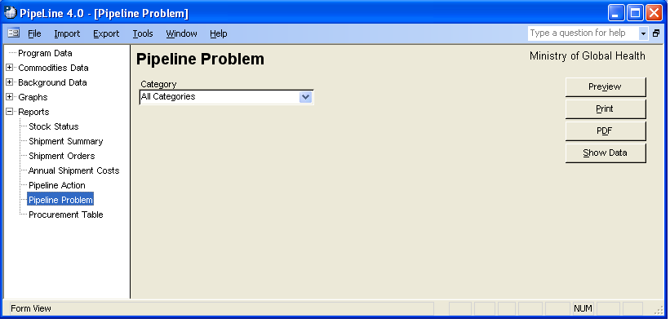
Figure 7-10—Pipeline Problem report screen The Pipeline Problem report screen is displayed (see Figure 7-10).

Limiting the Report’s Scope
You can limit the scope of the report.

- Click on the arrow next to the Category field, and select a category from the pull-down menu.
Or, select All Categories from the Category pull-down menu to include all the products in your program.

See page 25 for information on using the Show Data and Hide Data buttons.

See page 27 for information on previewing, printing, or creating a PDF of the Pipeline Problem report.

Procurement Table Report
This report displays data in the USAID CPT calendar year format. It applies the same formulas to calculate desired end of year stock, net supply, and supply shortfall for the CPT year and the following year. See the CPT Guidance Manual (available from USAID) for information on how these calculations are made. Request the product from USAID with the support of this report. If USAID agrees to supply the product, plan your shipments so that the supply shortfall is near zero.

Use this report when you talk to contacts familiar with the CPT format. It can be used to complete manual CPTs requested in USAID’s CPT Guidance as supporting documentation for USAID orders.

Creating a Procurement Table Report
The default period is five years, which includes the selected year, previous two years (historical), and following two years (forecast).

From the Tree View—

- Click on the Procurement Table Tree View option.

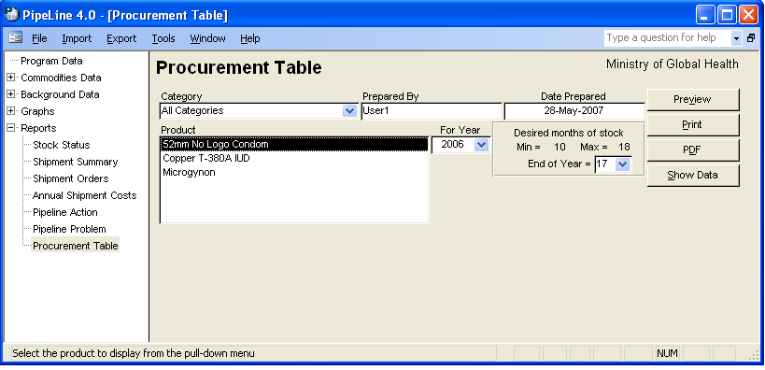
Figure 7-11—Procurement Table screen The Procurement Table report screen is displayed (see Figure 7-11).

Limiting the Report’s Scope
You can limit the scope of the report.

To select a specific category—

- Click on the arrow next to the Category field, and select a category from the pull-down menu.
Or, select All Categories from the Category pull-down menu to include all the products in your program.

Products associated with the selected category are displayed in the Product box.

- Click on the product you want included in the report.
Or, hold down the <Ctrl> key, and click on each product you want included in the report.

The Prepared By field shows the username of the person preparing the report. By default, PipeLine displays the username of the person currently logged into the system. To change the username—

- Highlight the entry in the Prepared By field, and type the name of the person preparing the report.

The Date Prepared field shows the date the report was prepared. By default, PipeLine displays the current system date. To change the entry—

- Highlight the entry in the Date Prepared field, and type the date the report was prepared.
 | Always use a four-digit year (for example, 2002, 2003, 2004, etc.).
The End of Year field (see Figure 7-12) enables you to determine how much stock you want to have on hand at the end of the year.
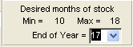
Figure 7-12—End of Year field

- Click on the arrow next to the End of Year field, and select the desired months of stock from the pull-down menu.

The For Year field displays the reporting year.

- Click on the arrow next to the For Year field, and select the desired CPT year from the pull-down menu.

See page 25 for information on using the Show Data and Hide Data buttons.

See page 27 for information on previewing, printing, or creating a PDF of the Procurement Table report.

Showing and Hiding Report Data
With the exception of the Annual Shipment Costs report, PipeLine report screens have a Show Data button that enables you to quickly view a sampling of the data to be included in a given report. This feature only works when one data set (product, type, supplier, etc.) is selected for a given category.

Showing Report Data
To use the Show Data feature—

- Select the criteria for a report based on the report’s instructions.

- Click on the Show Data button.

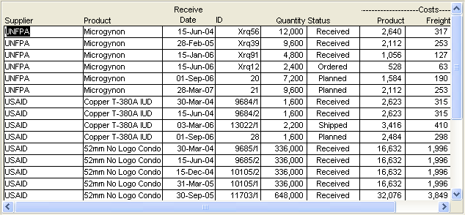
Figure 7-13—Example of Show Data display Data associated with the selected report are displayed on a screen similar to Figure 7-13. This example represents data generated by the Shipment Summary report.

Use the Scroll bar (if needed) to view all the generated data.

Hiding Report Data
The Hide Data button becomes active when report data is displayed on a given report form.

To hide the report data—

- Click on the Hide Data button.

Previewing and Printing PipeLine Reports
The procedure for previewing and printing PipeLine reports is the same for all types of reports.

Previewing a Report
To preview a report—

- Click on the Preview button.

The report is displayed onscreen. If you are satisfied with the data as presented, you can print the report from the preview screen.

- Click on the print icon to send the report to your default printer.

- Click on the close icon to return to the previous screen.

Office Links
The PipeLine Report Viewer Menu has a feature that enables you to export a displayed report to one or more of the programs associated with Microsoft Office. This feature is called Office Links.
 | You must have Microsoft Office 2000 or above installed on your computer to use the Office Links feature.
To use the Office Links feature—

- Select the report criteria, and click on the Preview button.

- Click on the Office Links option of the Tool Bar to display the Office Links pull-down menu.

- Select the file format you want to export to from the pull-down menu.

PipeLine prompts you to name the export file.

- Type the export file’s name in the name field, and click on the OK button.

PipeLine opens the Microsoft Office product associated with the file type where you exported the report.

Printing a Report
You can send a report directly to your default printer, without previewing it.

- Click on the Print button.

Creating a PDF of a Report
To create a PDF of a report without previewing it—

- Click on the PDF button.

To create a PDF of a report from the preview of the report —

- Click on the Preview button.

- Click on the Office Links option of the Tool Bar to display the Office Links pull-down menu.

- Click on the Send to PDF menu option to create a PDF of the report.
!! | To create a PDF, you must first choose a PDF writer. For more information on choosing a PDF writer, see page A-6.

